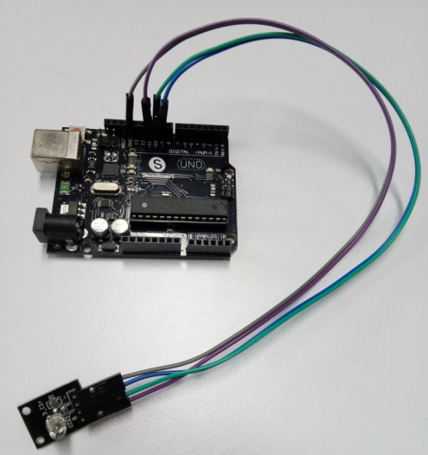

I. Overview:

RGB LED module consists of a plug-in full color LED made by R, G, B three pin PWM voltage

input can be adjusted

Section three primary colors (red / blue / green) strength in order to achieve full color mixing

effect. Control of the module with the Arduino can be achieved

Cool lighting effects.

Second, the product parameters:

Product Features:

1, the use of plug-in full-color LED

2, RGB trichromatic limiting resistor to prevent burnout

3, through the PWM adjusting three primary colors can be mixed to obtain different colors

4, with a variety of single-chip interface

5, the working voltage: 5V

6, LED drive mode: common cathode driver

Arduino test code：

int redpin = 11; //select the pin for the red LED

int bluepin =10; // select the pin for the blue LED

int greenpin =9;// select the pin for the green LED

int val;

void setup() {

pinMode(redpin, OUTPUT);

pinMode(bluepin, OUTPUT);

pinMode(greenpin, OUTPUT);

Serial.begin(9600);

}

void loop()

{

for(val=255; val>0; val--)

{

analogWrite(11, val);

analogWrite(10, 255-val);

analogWrite(9, 128-val);

delay(1);

}

for(val=0; val<255; val++)

{

analogWrite(11, val);

analogWrite(10, 255-val);

analogWrite(9, 128-val);

delay(1);

}

Serial.println(val, DEC);

}